Paul Romer

CSD340

December 8, 2024

Module 10

bioSite Final

Repo Link: <https://github.com/paulromer12/bioSite>

GitHub Pages Link: <https://paulromer12.github.io/bioSite/index.html>

Validated code:

index.html

about.html

hobbies.html

style.css

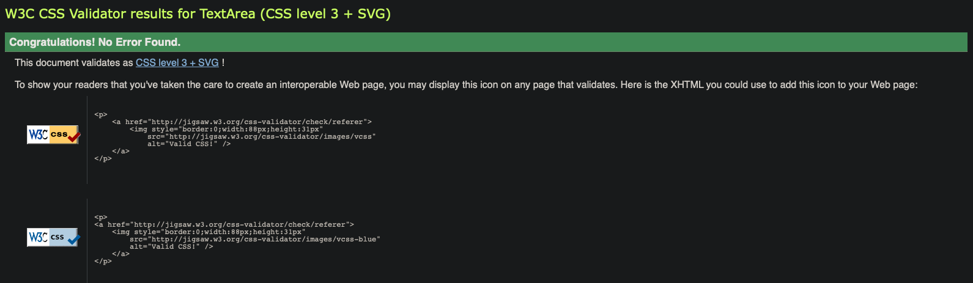

Final Screenshots:

index.html

about.html

hobbies.html

